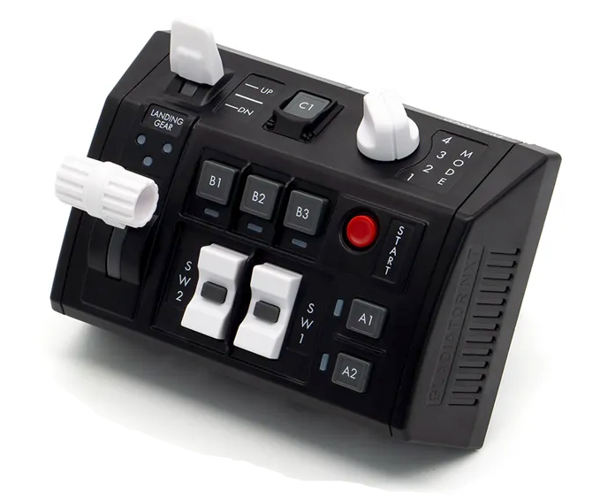  1xx - Controls | 2xx - Ground | 3xx - Flight | 4xx - A2A | 5xx - A2G | 6xx - Misc
104 - Controls - GNX SEM-V
U=Up, D=Down, N=Neutral, F=Forward, B=Backward, L=Left, R=Right, P=Press, S-*=Shift-*, L-*=Long-*

Landing Gear
- U: Landing gear up
- N: --
- D: Landing gear down
Flaps Switch
- U: Flaps Up
- N: --
- D: Flaps Down
SW1 Rocker Switch
- U: Canopy open
- P: Canopy lock
- D: Canopy close
SW2 Rocker Switch
- U: Cut drag parachute
- P: --
- D: Deploy drag parachute
- S-U: AAR Switch - ALL
- S-P: AAR Switch - INT
- S-D: AAR Switch - OFF
Start Button
- P: Jettison button
A1 Button
- P: --
A2 Button
- P: --
B1 Button
- P: --
B2 Button
- P: --
B3 Button
- P: --
C1 Button
- P: --
Mode Knob
- 1: --
- 2: --
- 3: --
- 4: --

